NEWSLETTER
City of East dubuque
 | ISSUE NO 2 | AUGUST 2022 | VOL 2
Topic 01
The City of East Dubuque’s update on the East Dubuque Police Department Project
Topic 02
Sand Prairie Fiber and their six-step process to build a fiber neighborhood. Sign up today!
 | Upcoming Project: East Dubuque Police department
 | With the current police station deteriorating, and an opportunity to submit the project for a Rebuild Illinois Fast-Track Public Infrastructure Program grant through the State of Illinois Department of Commerce and Economic Opportunity (DCEO) the city partnered with Origin Design to create a new police station and Community Funding and Planning Services for funding. |  |  |  | Because our Fire Station project was submitted first for funding, there is a possibility that the Police Station project will be put on hold. These projects will go to bid in the fall which will give the city a better idea on what the next steps will be. | Topic 03  City Manager Letter to Indian Hills residents.

ISSUE NO 2 | August 2022 | VOL 2
SAND PRAIRIE
Fiber Internet
Fiber internet brings speeds far superior that to DSL, cable, or satellite. Unlike traditional internet services, fiber provides better reliability, faster speeds, and lower latency. Other benefits of our fiber internet services include no monthly/yearly contracts, no data caps, and a top-of-the-line 1G managed wireless router is also included into these packages. A world-class, 100% fiber optic network connection is provided directly to your home eliminates the bottleneck experience on shared connections.
Fireworks Reminder: |  |  |  |  |  | 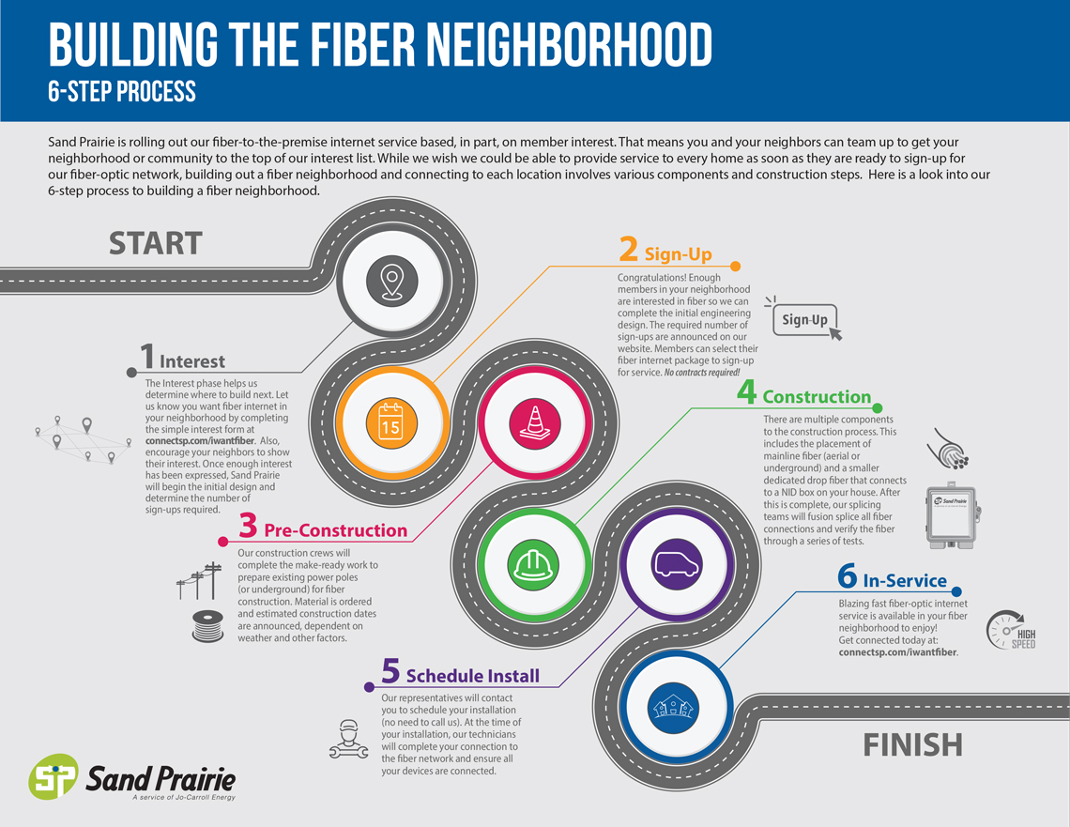

august Calendar
08  6:00 pm: City Council Meeting |  |  | 13  Noon – 9: 00 pm: Wingfest

22
6:00 pm: City Council
Meeting
